Task 1: Scan Your Local Network for Open Ports

Objective: Learn to discover open ports on devices in your local network to understand network exposure.

Tools: Nmap (free), Wireshark (optional).

Nmap – For scanning port and devices

Wireshark – For packet capture and traffic analysis.

Step-1 Install Nmap

Step-2 Local ip find using cmd run “ipconfig”

Step-3 Perform TCP SYS Scan

Command : nmap -sS 172.20.10.0/24 – This detect open TCP port on your all subnet.

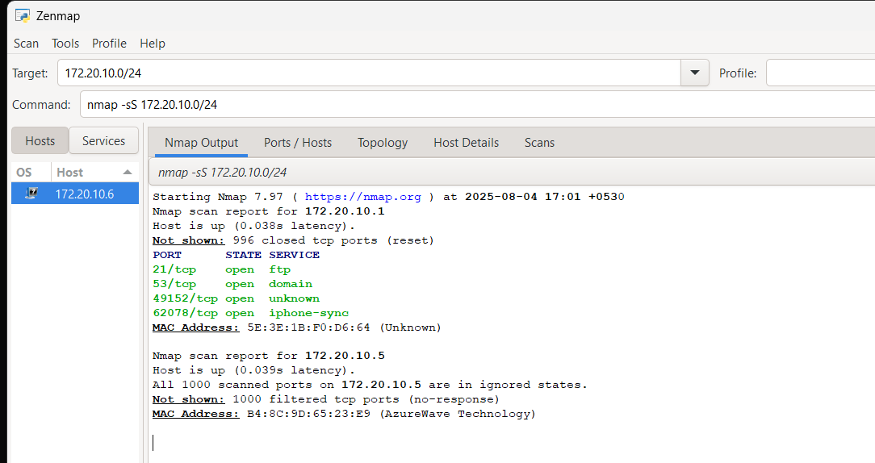

Step-4 Note down Ips and Open ports

Stpe-5 Cature Packet with Wireshark Start capture on active interface while scanning. - Filter packets with 'tcp' to view SYN packets

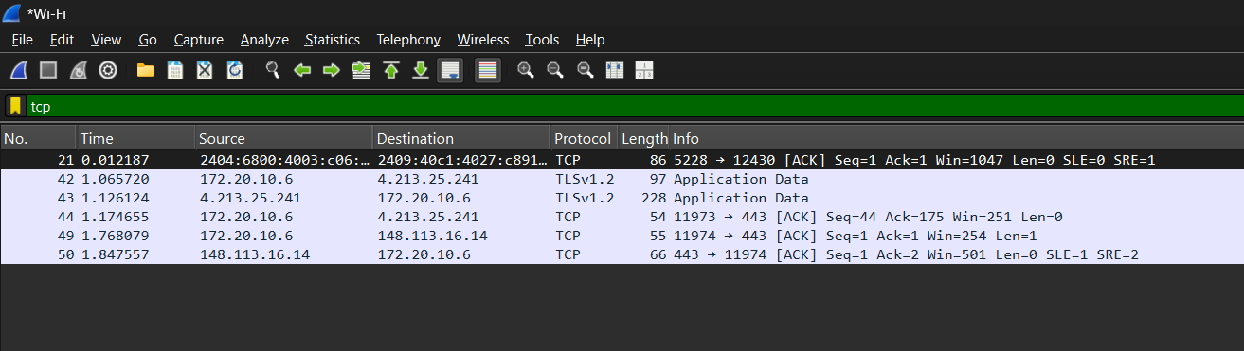

Stpe-6 Save both nmap and wireshark file.